LOGIC GATES

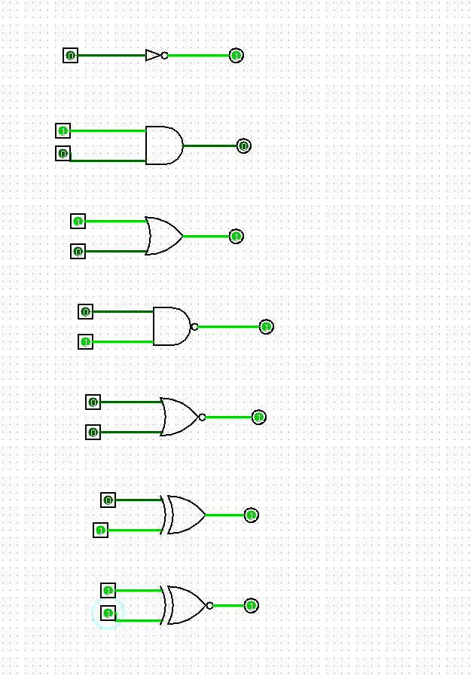

HALF ADDER AND FULL ADDER

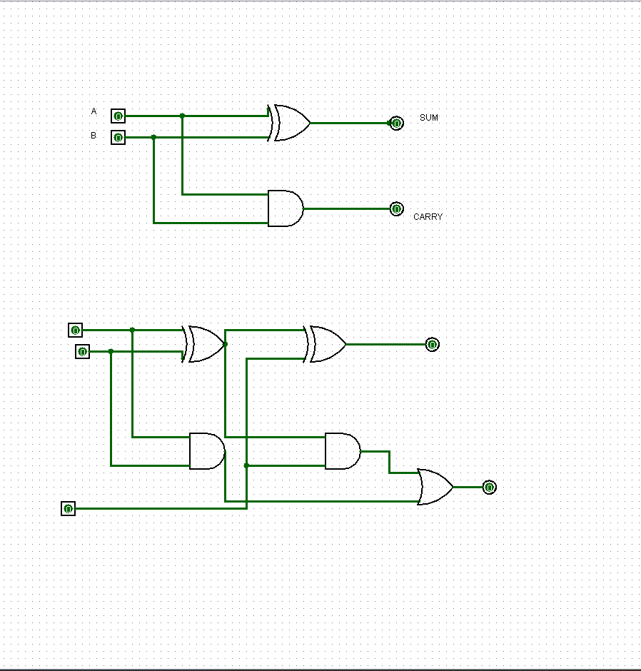

HALF SUBTRACTOR AND FULL SUBTRACTOR

